**World Quant University**

**Professor: Tiberiu Stoica**

**Econometrics**

Nikolas Lippmann Pareschi - [nikolaslippmann@gmail.com](mailto:nikolaslippmann@gmail.com)

**Mini Project 5: Quantifying the Maximum Expected Loss**

### Problem 1:   Quantify the Maximum Expected Loss for the next day using a Value-at-Risk (VaR) model.

Confidence level: 95%  
Volatility: 2.5%  
Current stock price: $126  
Implement VaR in Python and Excel.

Problem 1 in excel:

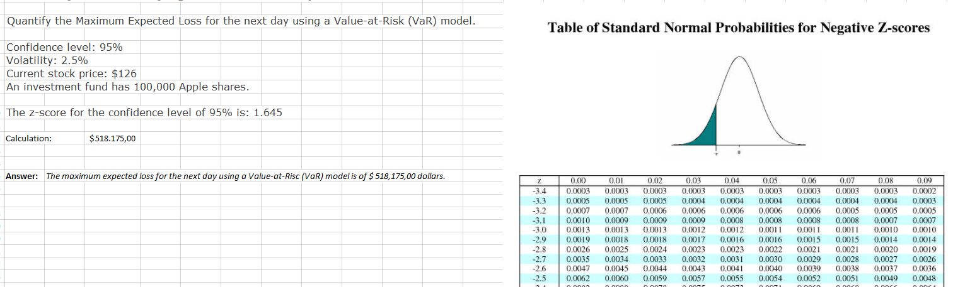

Python:

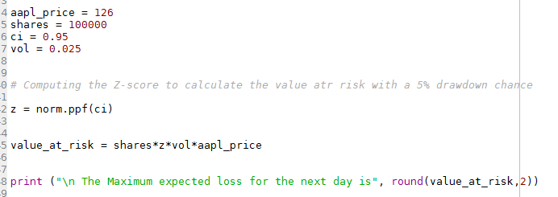



### Problem 2. Quantify the Maximum Expected Loss for the next day using a Value-at-Risk (VaR) model.

Confidence level: 95%  
Volatility: Forecasted  
Forecast the volatility using a GARCH(1,1) programmed in Python.  
Stock price: closing price from Google Finance, Yahoo Finance, Quandl, CityFALCON, or another similar source

Code:

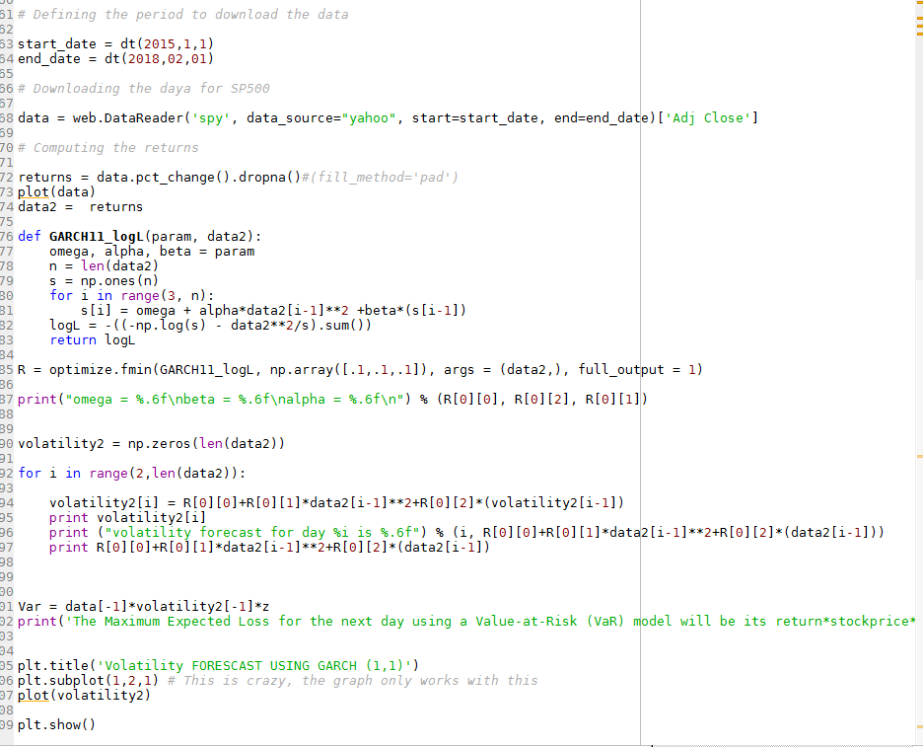

Results:

